Alphabet reports an operating expense line item called “Alphabet-level activities” that it describes as “primarily reflect[ing] expenses related to our shared AI research and development.” These were ~$16 billion in 2025, and $5.4B in Q1 2026 (~$22B annualized)

This makes sense as a reporting practice because Google spends resources via DeepMind R&D to produce Gemini models that are a shared input to all their business segments, so those expenses can’t be cleanly allocated to a specific segment. This reporting practice dates back to 2023, when Alphabet explains that because DeepMind (originally an acquired subsidiary) became more integrated with Google proper due to the Google Brain–DeepMind merger, DeepMind-related training expenses were moved from “Other Bets” line item to “Alphabet-level activities”.

What precisely does “Alphabet-level activities” mean?

In early 2026, Alphabet explained that this bucket contains several other expenses, including:
- certain AI-focused shared research and development activities, including employee compensation expenses and technical infrastructure usage costs associated with the development of our general AI models;
- corporate initiatives such as our philanthropic activities; and
- corporate shared costs such as certain finance, human resource, and legal costs, including certain fines and settlements.

This characterization has stayed similar over time. Alphabet wrote In 2023, Alphabet wrote that “[Alphabet-level activities] primarily include AI-focused shared R&D activities including development costs of our general AI models; corporate initiatives such as our philanthropic activities; corporate shared costs such as certain finance, human resource, and legal costs, including certain fines and settlements.” This language is essentially identical in 2024. In 2025, the full description of this expense category stays the same, but they add a briefer summary that only mentions shared AI R&D, apparently emphasizing that this category is predominantly AI R&D.

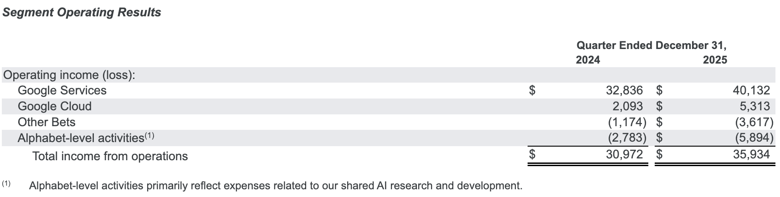

For 2025, total loss (expense) for Alphabet-level activities was $16.76 billion, up from $10.5 billion in 2024 and $9.186 billion in 2023. In 2026 Q1, this was $5.3 billion. The relatively slow growth between 2023-2025 is curious, though the fact that Alphabet-level activities include overheads like corporate philanthropy, HR, and settlements may partly explain this, since the AI-specific portion has probably been growing faster.

How does this translate to DeepMind compute? As Google says, this includes both employee compensation and “technical infrastructure usage costs” (compute). Presumably, inference compute for products is not included in this line item, since they’re part of their respective business segments. And I’m not sure whether all DeepMind-related R&D is in this bucket. For example, some development work may be specific enough to Google Services or Google Cloud to be reported in that bucket. For example, if the Gemini models used for Google Search overviews receive custom post-training, those expenses might be booked under Google Services.

Another uncertainty is how Alphabet bills compute costs to produce these expenses. DeepMind primarily uses Google-owned compute, so Google would be selling compute to itself. They probably use a cost figure, i.e. depreciation and amortization and operating expenses for the AI chips and data centers, instead of billing at the going rate for GPU-hours or TPU-hours. This makes Alphabet-level activities expenses apples-to-oranges with (e.g.) OpenAI’s and Anthropic’s cloud computing costs, since these expenses do not include a profit margin. (AI cloud is not enormously profitable, perhaps roughly 30%).

Overall, this line item is only mildly informative. Alphabet-level activities cost $16 billion in 2025, and this probably includes most of DeepMind’s R&D costs. But translating this to compute is difficult because this expense includes DeepMind employee compensation as well as compute, some part goes to non-AI expenses like philanthropy, HR, and legal settlements, some part of DeepMind R&D expenses might not end up in this bucket if they’re product-specific, and this does not include inference costs.

Still, it does provide a rough upper bound on DeepMind’s R&D compute expenses. They were probably well under $16 billion in 2025 (or $5 billion in Q1 2026), since most DeepMind R&D compute expenses likely fell into an $16 billion expense bucket that included DeepMind employee compensation and miscellaneous expenses.

$16 billion is also equal to OpenAI’s total compute expenses in 2025 ($8 billion for R&D alone). These numbers are not directly comparable for the variety of reasons enumerated above. But it provides a sanity check that OpenAI and DeepMind’s compute expenses weren’t vastly different in 2025.

